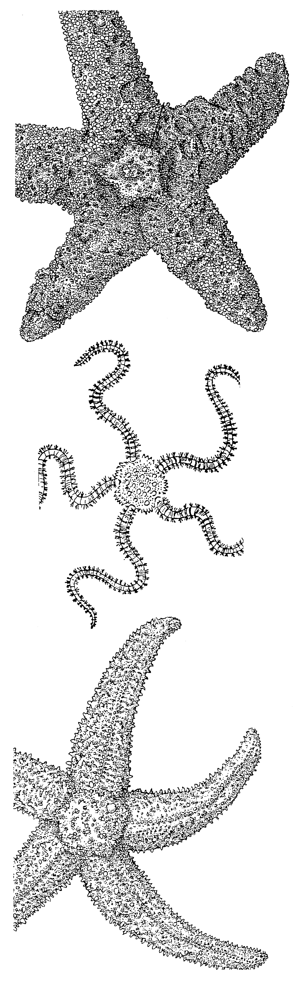
2018 WINTER TERM
Illustrations by Lynn Rudy from Oregon Estuarine Invertebrates
OREGON INSTITUTE OF MARINE BIOLOGY
January 8 – March 23, 2018
oimb.uoregon.edu

The University's marine biology station at Charleston is an ideal location for the study of marine systems. Many habitats are within easy reach of the laboratory. To the north are 50 miles of sandy beaches, and to the south are extensive rocky shores. OIMB is at the entrance to Coos Bay and adjacent to the South Slough National Estuarine Research Reserve; estuarine and open ocean habitats are only minutes away. Classes meet all day with a maximum of 24 students, allowing considerable interaction between students and faculty, and fostering an intensity of learning. The program is designed for juniors and seniors majoring in marine biology, biology, general science, and environmental science. Field trips and lab activities are emphasized. All students must have completed either BI 211 - 213 or BI 281H-283H or an equivalent core sequence in biology. UO students register using DuckWeb, non-UO students use a guest registration found on the OIMB web page. OIMB scholarship information is on the OIMB website.

BI 390 Animal Behavior (4 quarter hour credits) How and why animals behave, and how animal behavior is studied. Mechanisms of behavior, behavioral ecology, and sociobiology. Meets Thursdays 8:30am-5:00pm and Fridays 10:00-10:50am. Instructor: Alan Shanks
BI 457/557 Marine Conservation Biology (5 quarter hour credits) Marine Conservation Biology is the applied science behind the maintenance of biodiversity and the management of marine resources. We will examine prevailing dogma from diverse user groups through close examination of applied conservation case studies. Using readings, seminars, and field trips we will think critically and communicate effectively about the consequences of diversity loss at the levels of ‘stocks’ species, ecosystems, and genetics. We will assess threats to biodiversity (e.g. invasions, diseases, fishing, mineral extraction), and mechanisms for dealing with these risks, with an emphasis on marine reserves. Meets Tuesdays 8:30am-5:00pm and Fridays 9:00-9:50am. Instructor: Aaron Galloway
BI 457/557 Molecular Marine Biology (5 quarter hour credits) An introduction to applying molecular biology to research using marine organisms. Lectures and readings examine the use of molecular data in taxonomy and systematics, population structure and conservation biology, and morphological and developmental evolution. Lab exercises include analysis and interpretation of existing data sets and the generation of new data using basic methods. Students acquire practical laboratory skills including collection and preservation of material for molecular work, DNA extraction, PCR amplification of suitable target genes, sequence analysis, and building and interpreting phylogenetic trees. BI 214 prerequisite. Meets Wednesdays 8:30am-5:00pm and Fridays 11:00-11:50am. Instructor: Svetlana Maslakova
BI 401 Undergraduate Research (2-10 quarter hour credits) Students conduct a research project under the direction of an OIMB faculty member. Email the person with whom you wish to work to arrange for registration. Limit 8 students.
It is possible to conduct an internship with a local agency (e.g. ODFW, Coos Watershed, the South Slough National Estuarine Research Reserve) during winter term. Details need to be arranged before term begins. For more information see the OIMB Internship page.

OIMB INFORMATION Tuition and fees are the same as those on main campus. Room is $77/week and students are provided with a kitchen and expected to cook their own meals. subject to fee increases. To apply return the application form on the reverse of this announcement. If you have questions about winter term courses contact OIMB. Email: oimb@uoregon.edu Phone: 541-888-2581. Or visit the Biology Advising office in Klamath Hall.

OREGON INSTITUTE OF MARINE BIOLOGY WINTER TERM 2018

SCHEDULE OF CLASSES

TUESDAY WEDNESDAY THURSDAY FRIDAY
BI 457/557 BI 457/557 BI 390 BI 457/557 9:00-9:50am
8:30am – 5:00pm 8:30am – 5:00pm 8:30am -- 5:00pm BI 390 10:00-10:50am
Marine Conservation Biology Molecular Marine Biology Animal Behavior BI 457/557 11:00-11:50am

APPLICATION
Return completed application to Tammy Trost, Oregon Institute of Marine Biology, PO Box 5389, Charleston, OR 97420 or email to ttrost@uoregon.edu with “2018 Winter Application” in the subject.
Applications are reviewed on a rolling basis until courses are full. UO students can register using DuckWeb.

NAME_________________________________________________________

MAJOR___________________Graduate/Undergraduate (circle appropriate) Year in school: SOPH JUN SEN

AGE_______ UO ID Number____________________________ Telephone_________________________

Home Address___________________________________________________________________________________

School Address___________________________________________________________________________________

E-mail Address____________________________________________

Do you want to apply for dormitory housing? Yes / No If Yes: Female / Male / UO Graduate Student

Housing includes a meal plan through our dining hall. Do you have any dietary restrictions and/or food allergies our cooks should be aware of? _______________________________________________________________
***Winter Term will likely not have an open kitchen due to lower enrollment, in which case students will be housed in cottages or dorms with kitchens

Do you want information on OIMB Scholarships? Yes / No The deadline for applications is December 1, 2017.

IF YOU ARE NOT A UNIVERSITY OF OREGON STUDENT: Please complete the guest student application page from our web page, and send copies of your transcript with this application. We will notify you of your acceptance within two weeks of receiving your application. Tuition rates for winter term are listed at: https://registrar.uoregon.edu/costs/tuition-fees

Please check below the courses you wish to take at OIMB. The recommended course load is 14 -16 credits

BI 457/557 Marine Biology: Marine Conservation Biology (5 credits) ________

BI 390 Animal Behavior (4 credits)________

BI 457/557 Marine Biology: Molecular Marine Biology (5 credits) ________

BI 401 Undergraduate Research (2-10 credits) __________

