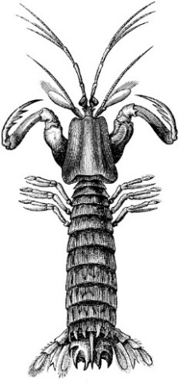
Introduction to Experimental Design and Statistics
BI 399

Instructor: Brian Bingham
Blackboard address: https://blackboard.uoregon.edu
Meeting time: M-F 8-5
E-mail: Brian.Bingham@wwu.edu

Course Objectives: An introduction to experimental design and statistics. This course is designed for juniors and seniors in the biological sciences who want to become more conversant with experimental design and the use of appropriate statistical tests. It will cover data analysis and tests commonly used in biological science. Topics will include descriptive statistics, hypothesis testing, analysis of variance, correlation, regression and experimental design. Course will emphasize practical approaches to real data using the rich marine environment of the Oregon coast.

Materials Needed:

- There is no text. We will use articles from the primary literature and class notes. You may want to have access to a good statistics reference book. I recommend the following, but any introductory statistical book will do:

Quinn, G.P. and M.J. Keough (2002). Experimental Design and Data Analysis for Biologists. Cambridge Univ. Press, Cambridge.

Sokal, R.R. and F.J. Rohlf (1995). Biometry. W.H. Freeman, N.Y.

Zar, J.H. (1999). Biostatistical Analysis. Prentice-Hall, Englewood Cliffs, N.J.

Evaluation of Work:

Midterm exam: 100
Final exam: 100
Homework assignments (8 @ 10 points each) 80
Literature presentations (2 @ 5 each) 10
Total: 290

Introduction to Experimental Design and Statistics: BI 399

 | Date |  | Discussion Topic
Aug | 15 | AM | What is (are?) statistics?
 |  | PM | Populations: Parameters and pitfalls
 | 16 | AM¹ | Comparing samples? Try a t
 |  | PM | Dealing with paired samples
 | 17 | AM² | What can we assume about assumptions?
 |  | PM | Clean glassware, big samples and other keys to power
 | 18 | AM³ | t-test = 1-way ANOVA
 |  | PM | Comparing multiple groups: Pairwise comparisons
 | 19 | AM⁴ | Testing more than one factor with ANOVA
 |  | PM | Midcourse Exam
 | 22 | AM | ANOVA, ANOVA again
 |  | PM | “Pseudoreplication” produces “pseudostatistics”
 | 23 | AM⁵ | Correlation: What is it and what can it tell us?
 |  | PM | Regression analysis for prediction
 | 24 | AM⁶ | Regression analysis for explanation
 |  | PM | Regression for dummies (dummy variables that is)
 | 25 | AM⁷ | Goodness-of-fit, contingency tables
 |  | PM | What can I do with complex data?
 | 26 | AM⁸ | Review
 |  | PM | Final Exam

*Homework assignment due

